ACSL
American Computer Science League
2012-2013

Contest #4

Senior Division

- Data Structures
1.
What is the internal path length of the binary search tree for:

NORTHCAROLINA

2. Data Structures
2.
Define the function SW as: switch from a stack to a queue or from a queue to a stack.
What would the next popped element be in the following queue?
PUSH(M), PUSH(E), PUSH(D), POP(X), SW, PUSH(I), PUSH(T), PUSH(E), POP(X), SW, POP(X), PUSH(R), PUSH(A), POP(X), POP(X), SW, POP(X), PUSH(E), PUSH(A), PUSH(N), SW, POP(X), POP(X), PUSH(S), PUSH(E), POP(X), PUSH(A), POP(X), SW

3. Digital Electronics
List all the ordered
triple(s) that make the
following circuit TRUE?

3.
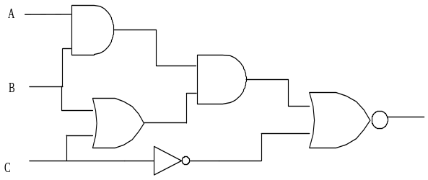

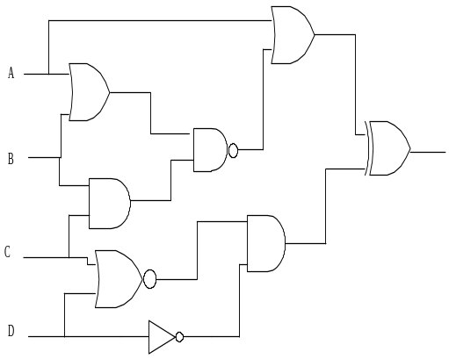
- LISP

Simplify the following LISP expression:

(CAR(CAR(CDR(REV(CDR ‘((2(1 2))(4 1 3)((2 1)3)4))))))

5.
4. Digital Electronics
How many ordered
quadruples make the
following circuit FALSE?
4.

